## Preface

Academic knowledge when augmented with the right practical exposure, serves as a double edged sword. It is very important to apply the academic knowledge in the practical life. If done so, education turns out to be worth. As bachelor students, our aim should not be only to learn theoretical concepts in the classroom but it becomes more important how we apply these concepts in practice.

In respect to the requirement of course prescribed by BKNMU University. We have finished our project to undertake the practical study of system analysis and design.

This project is on Desktop Professional and all the required details are included in the report. Care has been taken to take this project to maximum possible height at the same time maintaining the ease in interface

This report is a chronicle of what we did at development. This report also consists of sample Screenshots and database design features. This report reflects the knowledge and the valuable insight gained during development.We hope to be excused for any inadvertent omission or mistake.

## Acknowledgement

* It is our great pleasure to present our project report on “Library Management System” which we conceived the 5th Semester of BCA affiliated to **Bhakta kavi Narsinh Mehta University.** 

* As first, we would like to express our humble thanks and gratitude to the Director of SSSDIIT **Shree Rushikesh Swami** who has provided us such a great co-operate as progressive environment. Secondly, at the moment, we would like to express our deepest sense of gratitude to our deepest of **Prof. Paresh Vora** Who have contributed us the required information with special interest and guidance throughout our project work and treated us as their younger brothers. 

* Finally, I would like to thank all of them whose names are not mentioned here but have helped me in some way to accomplish the work. 

**Thank you…**

# Index

|  |  |  |
| --- | --- | --- |
| No | Particulars | Page No |
| 1 | **Project Profile** | **4** |
| 2 | **Requirement Analysis &**  **Questionary** | **5** |
| 3 | **Feasibility Study**   * Technical Feasibility * Economic Feasibility * Operational Feasibility | **8** |
| 4 | **Project Scheduling** | **6** |
| 5 | **GANTT Chart** | **7** |
| 6 | **PERT Chart** | **8** |
| 7 | **Data Dictionary** | **9** |
| 8 | **Data Flow Diagram** |  |
| 9 | **0 – level Diagram** | **18** |
| 10 | **1 – level Diagram** | **19** |
| 11 | **2 – level Diagram** | **21** |
| 12 | **Testing** | **23** |
| 13 | **Implementation & Maintenance** | **24** |
| 14 | **Limitation &**  **Future Enhancement** | **27** |
| 15 | **All Screen Layouts** | **28** |
| 16 | **Bibliography / References / Glossary** | **35** |

**Project Profile**

|  |  |
| --- | --- |
| Project Title : | Library Mangement System |
| Project Type : | Software Application |
| Developed By : | Hemang Gohel  Nikul Gauswami |
| College Name : | Shastri Swami Shree  Dharmajivandasji Institute of IT – Junagadh |
| Director : | Shree Rushikesh Swami |
| Stream : | B.C.A |
| Semester : | Semester – 5 |
| Academic Year : | 2019/20 |
| Time Duration : | Within 3 months |
| Project Guide : | Milind Sir |
| Project Evaluator : | Paresh Sir |
| Platform : | Front End - C#.Net Back End – MS Access |

**Cost Estimation**

|  |  |
| --- | --- |
| Cost Detail | Cost |
| Computer Rent | 2500 |
| Light Bill | 1000 |
| Database Design & Creation | 1500 |
| Code & Validation | 5000 |
| Extra Expense | 5000 |
| Total | **15000/-** |

*

## Identification of Need

➢ A request to receive assistance from information systems can be made for many reasons, but in each case someone initiates the request. When that request is made, the first systems activity, the preliminary investigation begins. 

* **Preliminary Investigation:**

* The purpose of the preliminary investigation is to evaluate project requests. It is not a design study, not does it include the collection of details to completely describe the business system. Rather, it is the collecting of information that permits committee members to evaluate the merits the project request and make an informed judgment about the feasibility of the proposed project. 
* We collect the information in this phase through questionnaire and personal interviews also. We have also note down the requirements of the clients. 

**Requirement Analysis**

* **Software Requirement :-**
* Front End : Visual Studio 12.0 & Above
* Back End : Access Database
* **Hardware Requirement :-**
* 4 GB Ram
* Intel i3 2.3GHZ Processer
* Windows 7/8/10
* **Functional Requirement :-**

1. Login :

Enter the Login ID

1. Dashboard :

Menu that user can choose explore Book , Books Details , Issue books ,

Return Books , Manage Books , Manage Students

1. Explore Books :

User can Search the Book by any type of Field that can be a Book Name , Author , Title , Description , Book ID , Language etc…

1. Book Details :

User have enter only Book ID / Book Number and at that time user can

See the all about of book Details

1. Issue Books :

User should be able to enter the details of Book and also enter the

Student Name & Student ID

1. Return Books :

User Should be given

1. Manage Books :

User can Add New Book & also Edit the Book Record

1. Manage Student :

User can Add the details of Students and also edit the details of student

**Questionary**

1. What is the title of your project?

Library Management System.

1. What do you want to create software or website?

Software Application.

1. Do you have any software Already?

No, do not have any software already.

1. What is the purpose of your software?

The purpose of software for manage the library details.

1. How long do you want to make in this software?

Approximately 3 month.

1. How many menus are your in this software?

There are 6 menus. Explore Books, Book Details, Issue Books, Return Books,

Manage Books, Manage Students.

1. This software is admin side or client side work?

No, there is only admin side software that will be manage by one person for

Library Management.

1. How many service are take part in the software?

In Software there is,

* User can add the books and also Edit / Delete the books records.
* User could add the student name and student Id for Issue & Return Books.
* User should add the record of Issue Books and add the return books details

In library management software.

1. Add the login page in Library Management Software?

Yes….Of course.

## Feasibility Study

* **Economical Feasibility:**

* Considering the clients for a library management system software. The cost of designing and development cost around Rs.15000/- . its also converts the cost of intenet access.
* The cost included for Library Management System project are with the general market and are acceptable to the client.
* **Operational Feasibility:**

* Client have one person for manage this software. 

* Person has basic knowledge of computer and data entry for library management. 

* Operational Feasibility aspects of the project are to be as an important part of the project implementation.

* This includes such design probability, maintaining, liability, supporting, data entering etc…

* **Technical Feasibility:**

=>Hardware Requirement :

|  |  |  |
| --- | --- | --- |
| Types of Hardware |  | Name of Hardware |
| Processor |  | Core i3 Intel Processor |
| RAM |  | 4GB |
| Harddisk space |  | 3GB |

=>Software Requirement :

|  |  |  |
| --- | --- | --- |
| Types of Software |  | Minimum Version Required for Software |
| Operating System |  | Microsoft Windows 7 or above |
| Front End |  | Visual Studio (12.0 & above) |
| Back End |  | Microsoft Access Database |

Gantt Chart

* A Gantt chart is a special type of bar chart where each bar represents an activity. The bars are drawn along a time line. The length of each bar is proportional to the duration of time planned for the corresponding activity.
* Gantt charts used in software project management are actually an enhanced version of the software project management. Each bar consists of a white part and a shaded part. The white part of the bar shows the length of time each task is estimated to take. The shaded part of the bar shows the slack time.
* In order to estimate the time durations for various activities, usually managers let the engineers themselves estimate the time for an activity they might be assigned to. However, some managers prefer to estimate the time for various activities themselves. Many managers believe that an aggressive schedule motivates the engineers to do a job better and faster.
* However, careful aspects, but also cause schedule compromise on intangible quality aspects, but also cause schedule delays. A good way to achieve accuracy without creating problems is to let people set their own schedules.

Peart Chart

* PERT (Project Evaluation and Review Technique) charts consist of a network of boxes and arrows. The boxes represent activities and the arrows represent task dependencies. PERT charts are a more sophisticated form of activity chart. Where instead of making a single estimate for each task, pessimistic, likely and optimistic estimates are made. The boxes of PERT charts are usually annotated with the pessimistic, likely, and optimistic estimates for every task. There are thus not one but many critical paths, depending on the permutations of the estimates for each task. This makes analysis of critical path show by using shaded boxes. The PERT chart representation of the MIS problem of show follows.

* PERT charts incorporate additional information about the time when an engineer doses a task. This information is not available is helpful in planning the utilization of resources, while the PERT charts is more useful for monitoring the timely progress of activities. Also, parallel activities in a project can be easily identified using a PERT chart. 

16-09-2019

05-09-2019

10-08-2019

16-9-2019

10-8-2019

**Data**

**Dictionary**

**Coding**

**Testing**

07-07-2019

10-08-2019

10-09-2019

**Requirements**

**Project**

**Scheduling**

16-9-2019

7-7-2019

**Implementation**

16-09-2019

20-08-2019

15-07-2019

**Feasibility**

**Study**

16-9-2019

20-8-2019

15-7-2019

**Maintenance**

**Designing**

**Data Dictionary**

* + A data dictionary is created to define the content of each dataflow, data store and each process to avoid confusion about what particular data is collected and store.
  + A data dictionary is a list of the elements in a system. In a data dictionary you will find a list of all the elements and organization needs. The data dictionary stores data flow, data stores and processes.
  + All the database tables are created in MS ACCESS.

* **Database Tables:** 

**Manage_Books**

|  |  |  |  |  |  |
| --- | --- | --- | --- | --- | --- |
| Field Name | Type | Size | Null | Default | Auto Increment |
| Book id | Number | 5 | no | - | yes |
| ISBN_Number | Long Text | 50 | no | - | no |
| Title | Short Text | 50 | no | - | no |
| Author | Short Text |  |  |  |  |
| Description | Long Text |  |  |  |  |
| Publisher | Short Text |  |  |  |  |
| Book_Language | Short Text |  |  |  |  |
| Price | Number |  |  |  |  |
| Book_Year | Number |  |  |  |  |
| Pages | Number |  |  |  |  |
| Date Added | Long Text |  |  |  |  |

**Issue Books**

|  |  |  |  |  |  |
| --- | --- | --- | --- | --- | --- |
| Field Name | Type | Size | Null | Default | Auto Increment |
| Book id | Number | 5 | no | - | yes |
| Student_Roll_No | Number | 50 | no | - | no |
| Student_name | Long Text | 50 | no | - | no |
| ISBN_Number | Number | 10 | no | - | no |
| Book_Title | Short Text | 50 | no | - | no |
| Book_Author | Short Text | 15 | no | - | no |
| Issue_Date | Short Text |  |  |  |  |
| Due_date | Short Text |  |  |  |  |

**ReturnBook**

|  |  |  |  |  |  |
| --- | --- | --- | --- | --- | --- |
| Field Name | Type | Size | Null | Default | Auto Increment |
| Book id | Number | 5 | No | - | yes |
| Student_Roll_No | Number | 50 | No | - | no |
| Student_name | Long Text | 50 | No | - | no |
| ISBN_Number | Number | 10 | No | - | no |
| Book_Title | Short Text |  |  |  |  |
| Book_Author | Short Text |  |  |  |  |
| Issue_Date | Short Text |  |  |  |  |
| Due_date | Short Text |  |  |  |  |
| Submission_date | Short Text |  |  |  |  |
| Fine | Short Text |  |  |  |  |

**New Students**

|  |  |  |  |  |  |
| --- | --- | --- | --- | --- | --- |
| Field Name | Type | Size | Null | Default | Auto Increment |
| Roll_Number | Number | 50 | - | - | no |
| Student_Name | Long Text | 50 | - | - | no |
| Date_of_Birth | Short Text | 10 | - | - | no |
| Address | Long Text | 10 | - | - | no |
| Email | Short Text | 10 | - | - | no |
| Phone_Number | Short Text |  |  |  |  |
| Course | Short Text |  |  |  |  |
| Admission_year | Short Text |  |  |  |  |

**Data Flow Diagram** 

* Data Flow Diagram (DFD) is a graphical and pictorial view of all the process of all the system and transaction. If the any process in the system then that process should covered in the DFD. DFD are very useful for solving the problem occurred during the development of the software.
* By this software we can also get the flow of the diagram and we can understand the customer’s requirements very easily by these diagrams will all of the advantages this diagrams are very useful in the process of developing the process.
* The DFD can be divided into many diagrams. Here, three levels of the DFD which are as following:
* Context(Zero) Level
* First Level
* Second Level o Symbols are used in the DFD are as following: 

**Process:**

* When any new process starts, it should write in this round shape.
* The round shape also displays from which state the process should be start.
* The round shape describes the flow of the data.

**External Entity:** 

* A source of destination of data which is external to the system.
* The process has many entities and it also have many sub-entities or external entities. That type of entities are described or written in above shape.

**Data Flow:** 

* It is the flow of data .It may be in the form of document, letter, etc.
* This type of arrow signs indicates the flow of the data in the project. It describes from which part the data is come and in which side the data will flow. This arrow keys are full of various meanings.

**Database Table:** 

* + - Any stored data can take with no reference to the physical method of storing.
    - It shows the process of the storing of the data and the data’s address can also be stored in this signs.

**Data Store:**

* + It is Use for store Data Base.
  + This Shape is used for Represent a Particular Database.

**0-level**

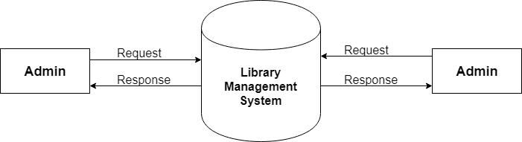

**1-level**

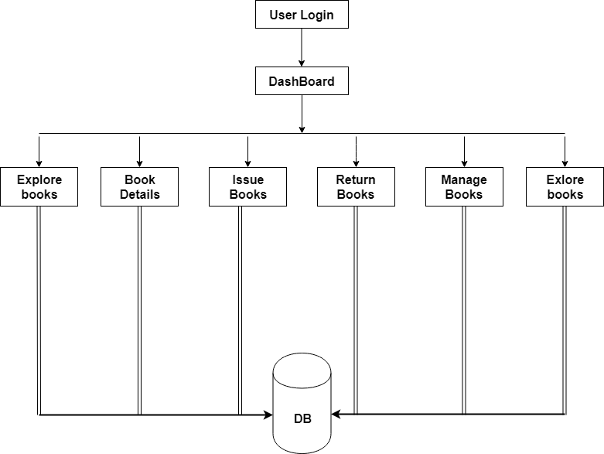

**2-level**

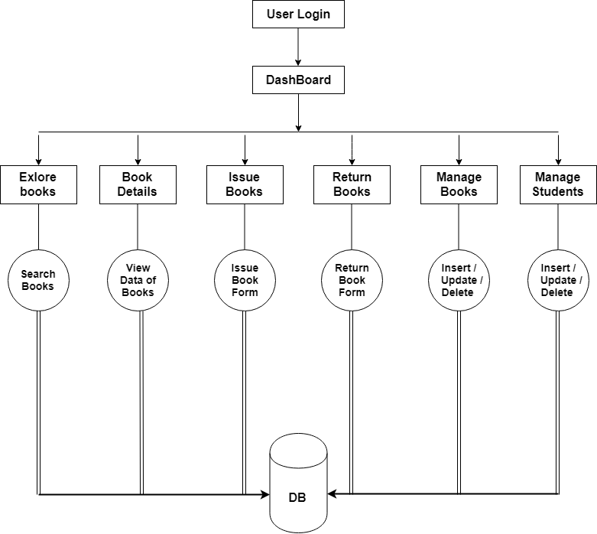

## Testing

* Software Development Life Cycle (SDLC) includes a series of production activities one of this is testing.
* Testing is a process of executing a program with the intent of finding an error.

* Testing is the most important element to be considered for providing quality software and it represents the ultimate review of specification, design and coding.
* The success or failure of the software as a system mainly depends on testing. Software Developer spends 40% to 50% of their total development time on testing.
* There are several SDLC techniques and development model. I have focused on Prototype Model. I have followed the prototyping model to develop this Software.
* The development of software system involves a series of production activities where opportunities for injection of human fallibility are enormous. Error may begin to occur at the very inception of the process where the objectives may be erroneously or imperfectly specified, as well as later design and development states. Because of human inability to perform and communicate with perfection, software development is accompanied by a quality assurance activity.
* Testing is program consists of providing the program with a set of test inputs and observing if the programs behave as expected. Under which a failure occurs are noted for debugging and correction. The following are some commonly used terms associated with testing.
* **UNIT TESTING** 

* + Unit testing is under taken when a module has been coded and successfully reviewed in this section we first discuss the environment needed to perform unit testing. 
  + Here in this project we test each and every module and forms of website individually when it is completely coded. 
  + There are some methods for unit testing are as follows.  

* **Black – Box Testing**

* + Equivalence Class Partitioning
  + Boundary Value Analysis

* **White – Box Testing**

o Statement coverage

o Condition Coverage

o Path Coverage

o Data Flow - Based Testing

* **Grey – Box Testing**
* Combination of a Black & White Box
* Test of Software
* **INTEGRATION TESTING** 

The primary objectives of the integration testing is to test the module interface in order to ensure that there are no error in parameter passing when one module invokes another module. During integration testing different module of system as per integration plane the integration plan specify the steps and the order in which module are combine to realize the full system. 

## Implementation and Maintenance

* Implementation refers to the entire effort associated with a new system. The implementation of a web application involves longer term issues after the system has been designed and installed.
* The implementation is processed from review and reports from developer cover the following areas:
  + Good working conditions…
  + Useful for gathering information…
  + Changing in the pages at a time…
  + Attractive layouts…
  + Working for as per requirements…

**Limitation**

* This software is a offline. So that user can easily work. This software is a only for Admin user.
* This software is only for user Experience so what not more services given in the software.

**Future Enhancement**

* We are Trying to solve the all basic problem. So that user can get more Features in our Software
* We are working on Below Things,

1)Implement more Facilities

2)Better Designing

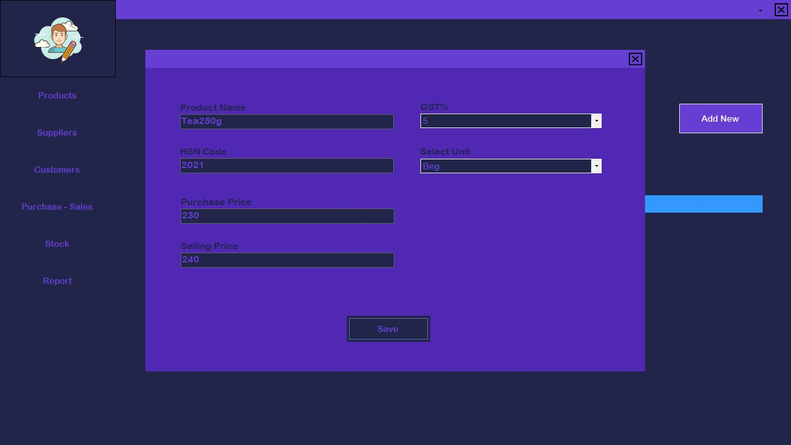

* 1. **Suppliers**

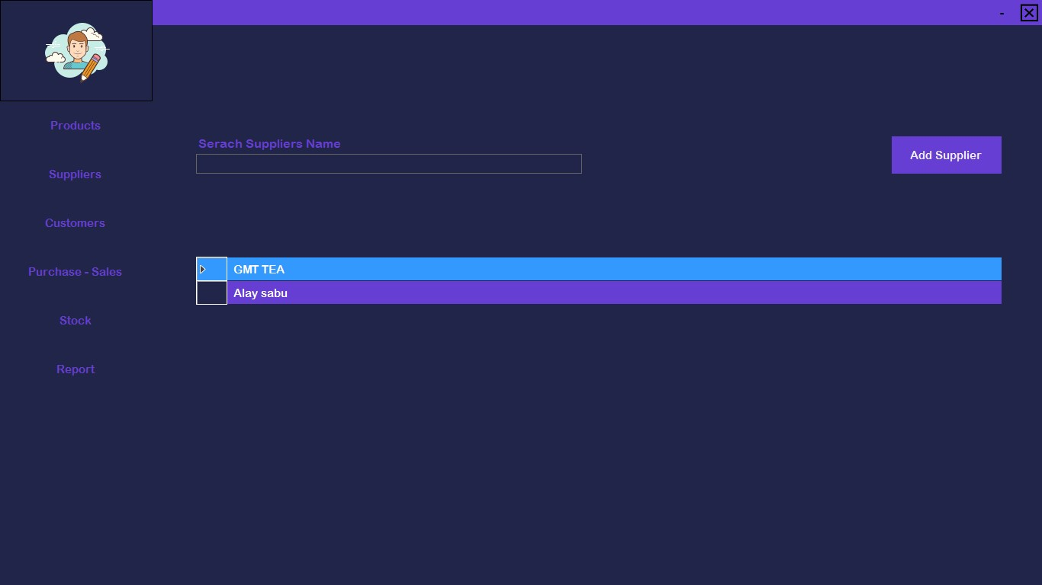

* 1. **Add New Supplier**

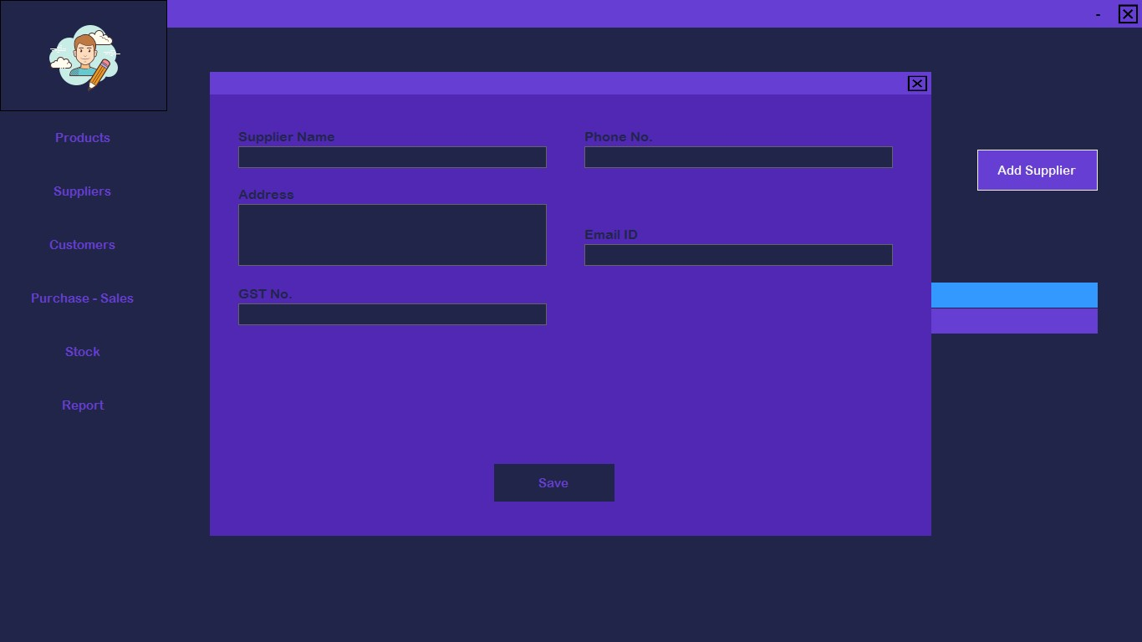

* 1. **Customers**

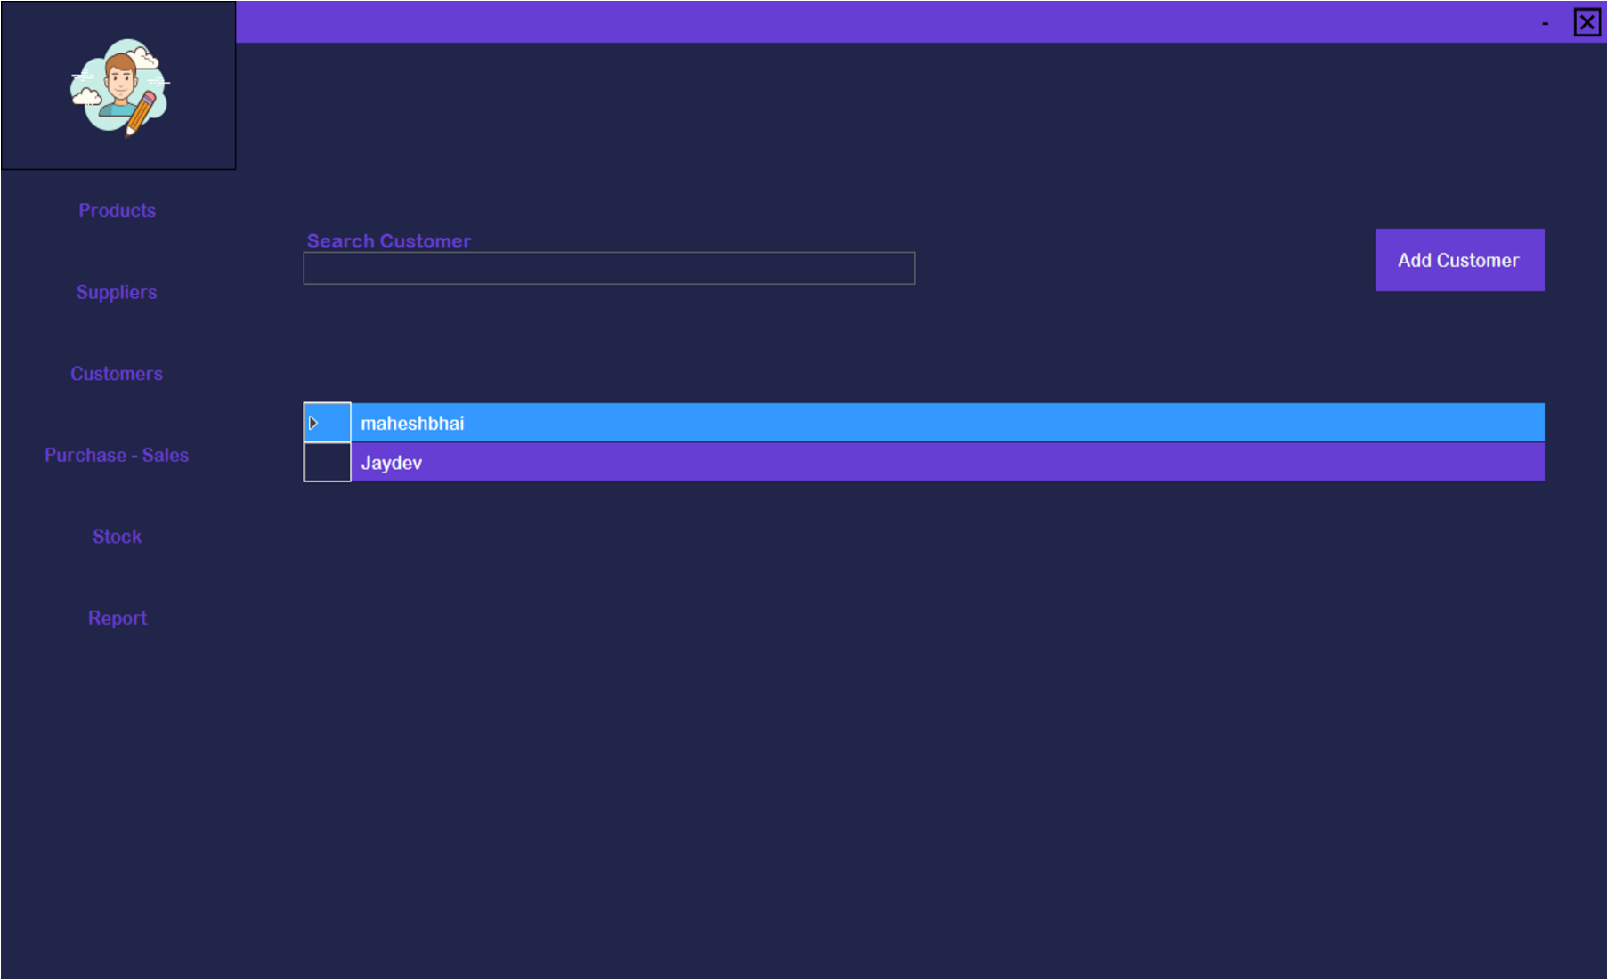

* 1. **Add New Customers**

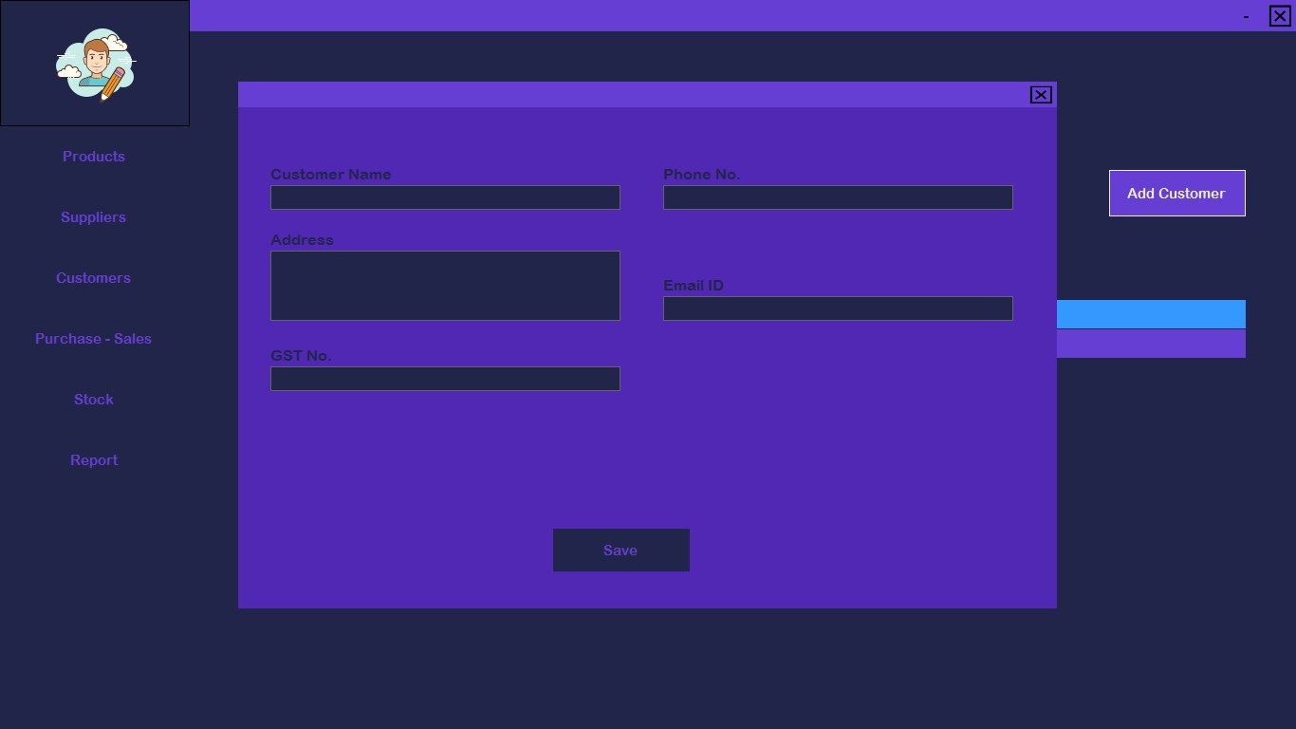

* 1. **Purchase**

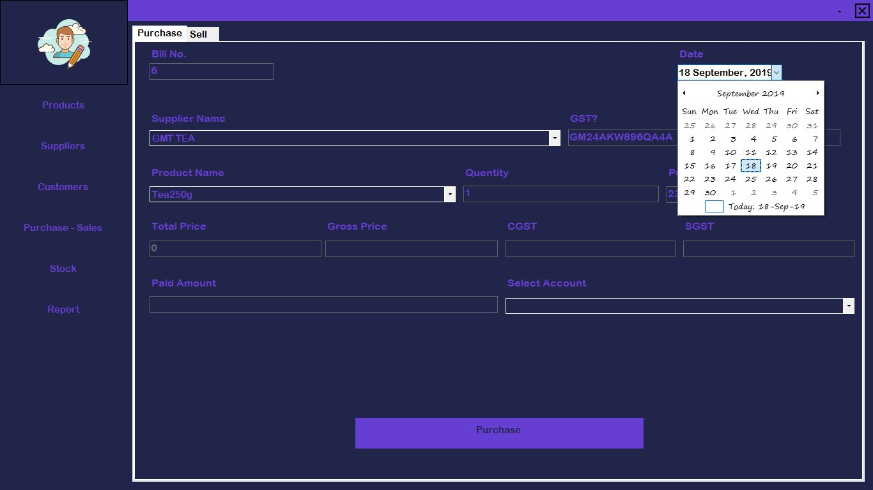

## 9) Sell

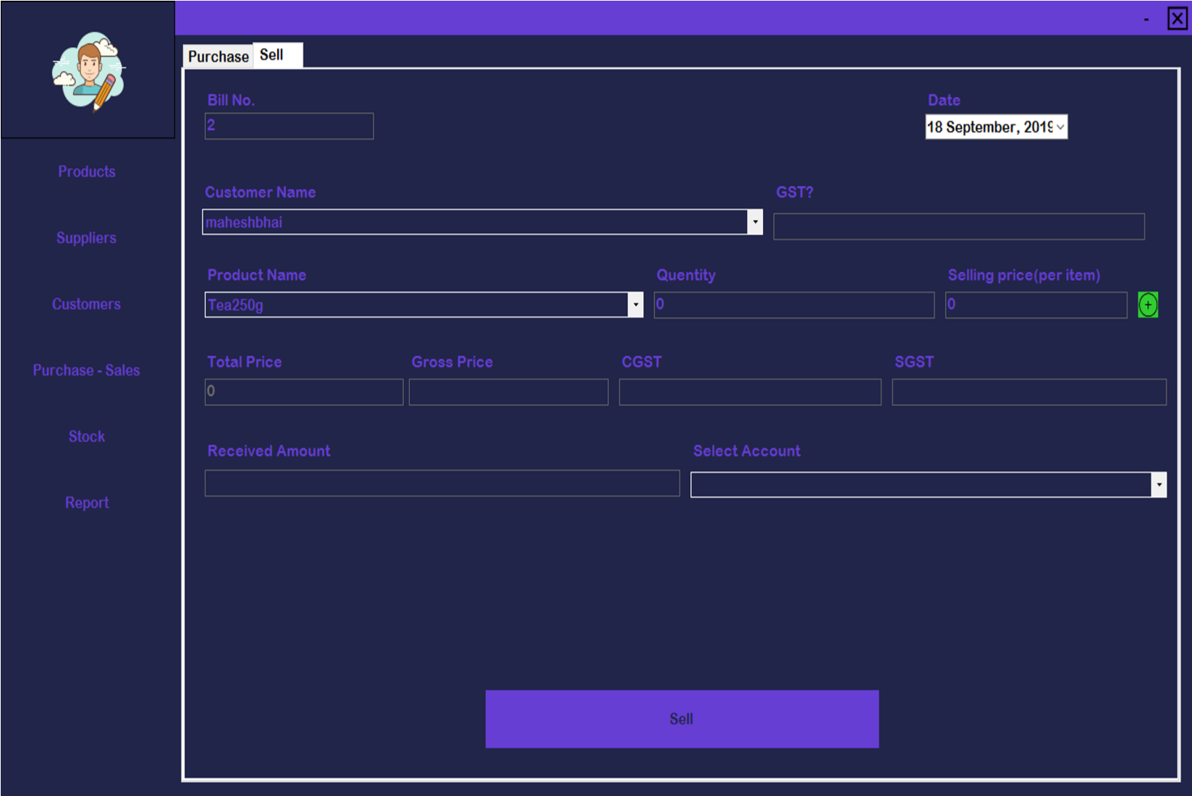

1. **Stock**
2. **Report 12) Shop Details**

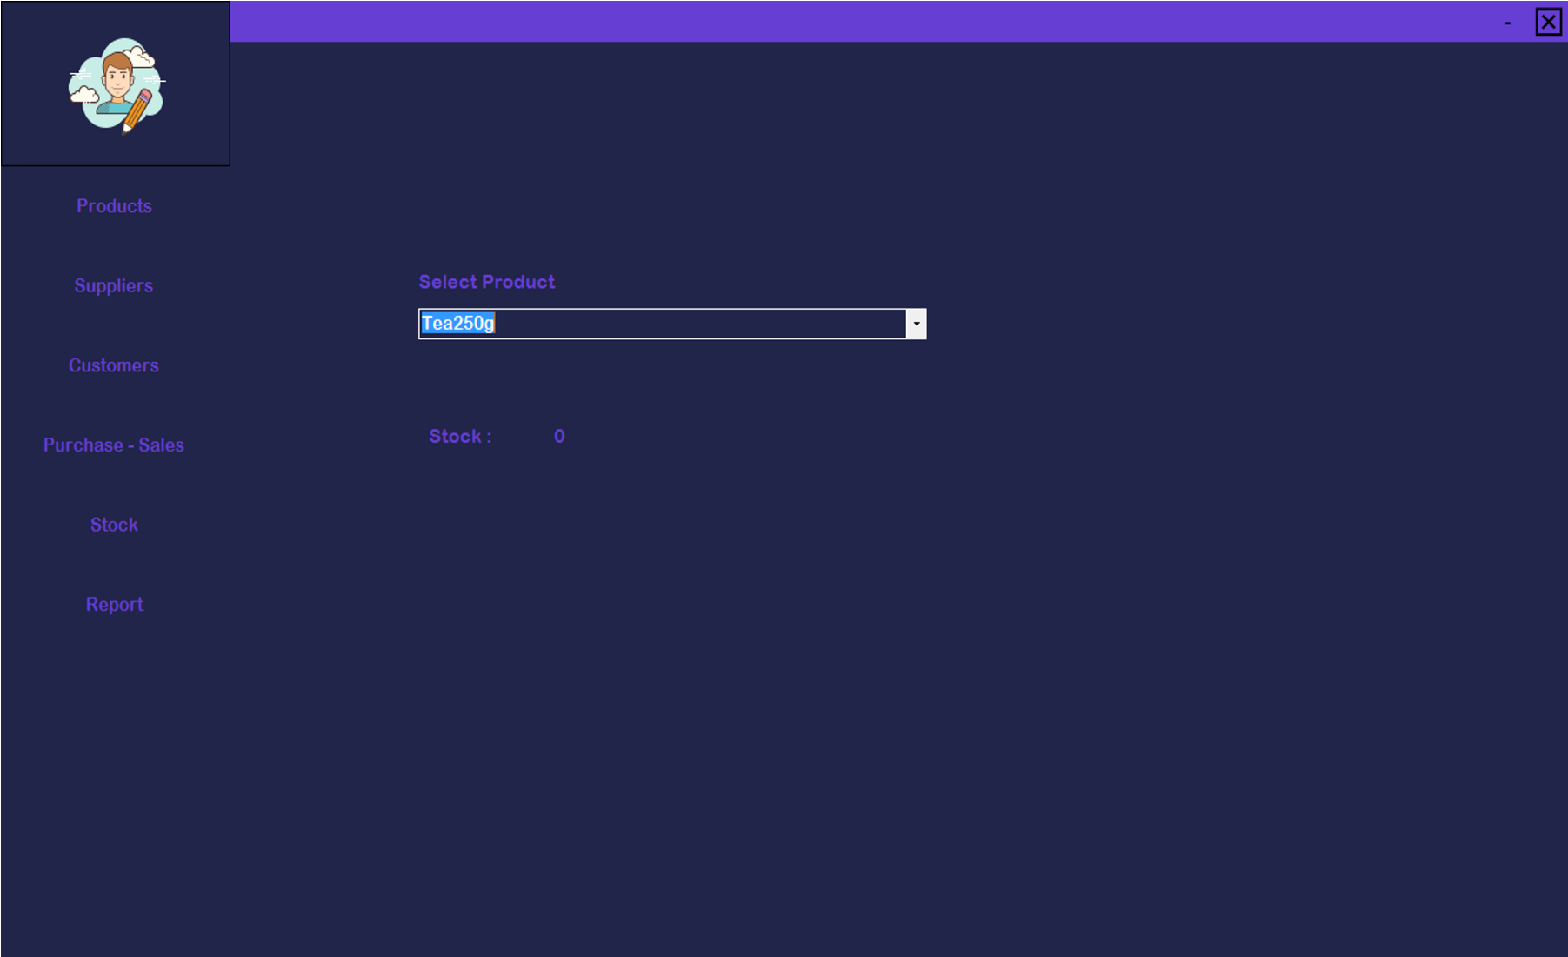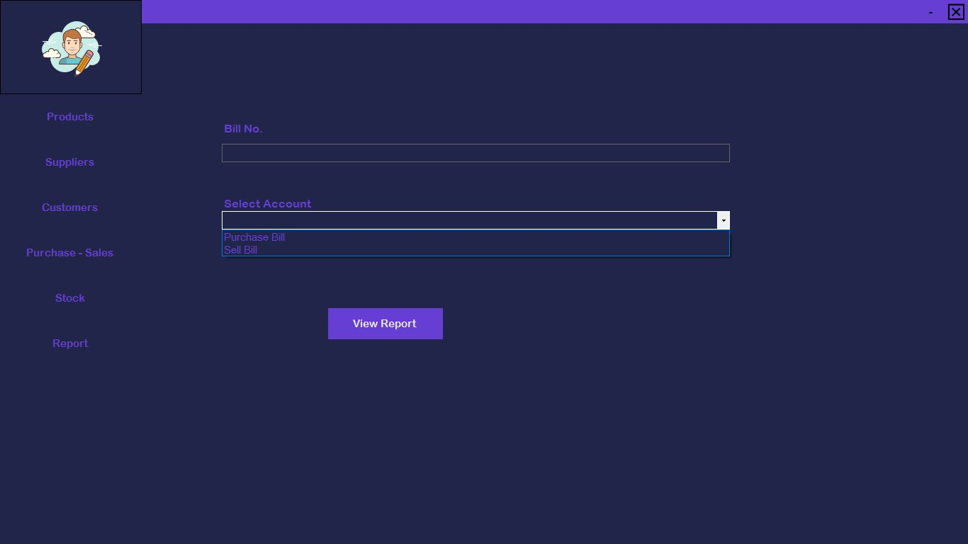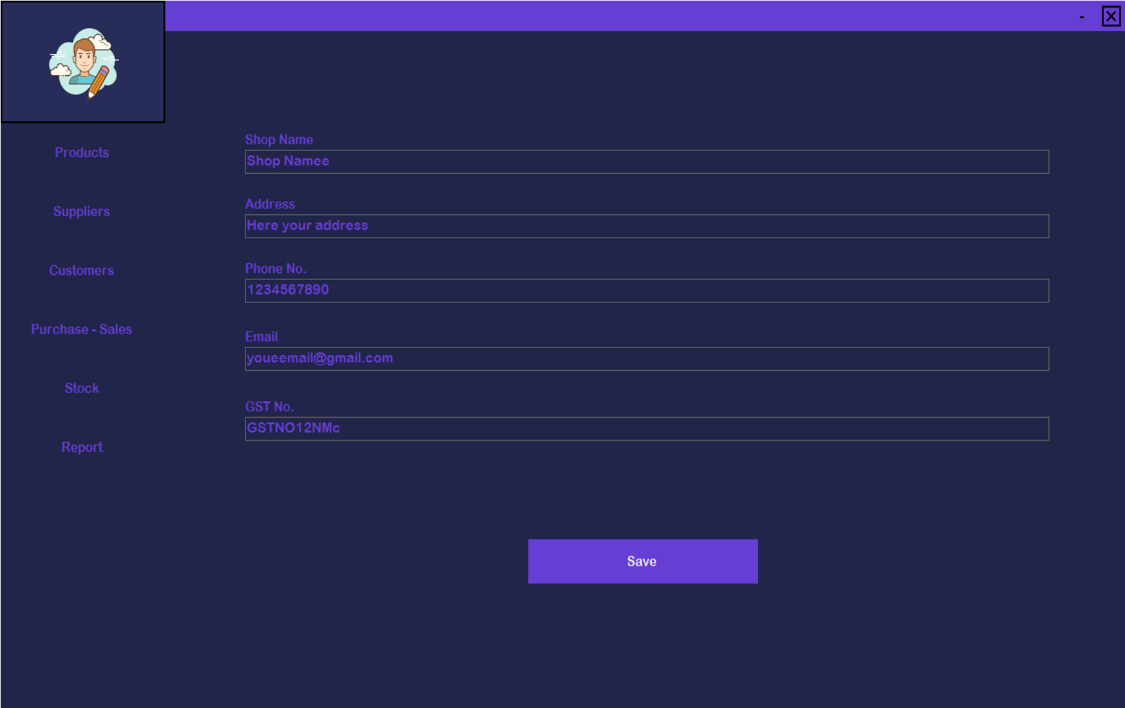

**Bibliography**

* + <https://www.c-sharpcorner.com/>
  + <https://stackoverflow.com/>